**SCHOOL OF ELECTRICAL ,ELECTRONIC AND COMPUTER ENGINEERING**

**ENEL4VW: VACATION WORK COURSE**

**VACATION WORK REPORT**

**NAME : KASHMIL SUBBAN**

**STUDENT NUMBER: 212501080**

**DISCIPLINE : ELECTRICAL ENGINEERING**

**COMPANY WHERE VACATION WORK WAS PERFORMED : SASOL**

**PERIOD OF VACATION WORK:**

1. **02 DECEMBER 2013 – 21 DECEMBER 2013**
2. **05 JANUARY 2014 – 24 JANUARY 2014**

CONTENTS

SYNOPSIS 3

INTRODUCTION 4

OUTLINE OF WORK 5

DETAILS OF WORK 6

CONCLUSION 7

BIBLIOGRAPHY 8

ACKNOWLEDGEMENTS 9

APPENDIX 10

[1] Pump with damaged electrical panel received from mine 10

[2] Electrical control panel for pump with circuit diagram with earth test lockout 10

[3] M20 motor protection relay 11

[4] Complete process overview 11

[5] Repairs of motors 12

[6] Risk assessment form and safety wear 13

[7] Repairs of electric pump panels 14

[8] Final product after completion 14

[9] Flameproofing certificate and specifications 15

[10] Earth fault lockout / circuit diagram of electric panel 16

[11] Certificate and description of earth test lockout 17

[12] Presentation done to line manager and other engineers 18

# SYNOPSIS

The purpose of this report will be to outline the activities that I have performed in the 6 weeks that I have carried out my vacation work at SASOL. This report will highlight the practical as well as the theoretical knowledge I have gained working with various types of machines ,tools and equipment. The work that was assigned to me is not Engineering in nature but forms a basis in helping to solve enginnering problems and flaws in design of machines and equipment which is only seen once you actually work with the equipment itself . Most of the equipment that I have worked with is used in SASOL coal mines that helps artisans and contractors in maintaining electrical machines and controls for keeping the supply of coal at its optimum that have been designed and implemented by engineers.

The tasks and knowledge gained during appointment at SASOL:

* Striping and re-assembling of water pump panels
* Striping and re-assembling of motors (ac and dc)
* Using software to programme and test M20 contol circuits used in water pumps
* Testing done on both water pump electric panels and motors (ac and dc)
* Dangers of mining
* Understanding how crucial coal is to SASOL and why eqiupment and machines play a vital role in the supply of coal
* Safety procedures
* Importance of flameproofing of equipment
* Understanding the many processes of SASOL
* Learning about tolerances of different materials and engineering specifciactions
* Housekeeping

# INTRODUCTION

I was appointed at the electrical section of SASOL MINING SM SURFACE SERVICES –SEC-CENTRAL WORKSHOP in Secunda which plays a vital role at SASOL in the coal mining process. At SASOL MINING SM SURFACE SERVICES –SEC-CENTRAL WORKSHOP equipment like water pump electric panels [10], dc and ac motors, shuttle cars , roofbolters and crushers are built and reconditioned. The demand for these machines and equipment are immense as they are used for extraction of coal underground. Coal is extremely important as it is the main resource used in the production of fuel and other various products that are produced at the SASOL plant. Some coal is also used in the generation of electricity that the plant uses for these processes.

During my vacation work period I was placed under Pieter Van De Walt and Gideon Adendorff who were my line managers at the SASOL MINING SM SURFACE SERVICES –SEC-CENTRAL WORKSHOP. I was then assigned to the water pump and motor build and recondition section and worked with many artisans that helped me understand the process of how these two types of electrical equipment were built, reconditioned and tested. The artisans that work in these two departments helped me more with the practical part of actually building and repairing motors and electric pump panels. The theoretical background and understanding of various components that are used were given to me by my manager and further explained by him. These included company records which consisted of circuit diagrams [10], photographs, flow charts and certificates.

The artisans that I worked with were

* Neilen Booysen
* Poppy Xaba
* Frits Marray
* Theuns Van Zyl

Who all perform various tasks in the manufacture of these products of the workshop. Although they are not engineers they made me aware of the various flaws in the design of motors and water pumps that pose challenges for them on the production line as well as for coal miner’s underground that may have been missed in the design process by engineers.

Talking to various engineers, inspectors and supply managers I was able to learn and understand the various stages of production, processes, supply , use of different types of machinery as well as well what really SASOL is all about and what products are produced by them.

# OUTLINE OF WORK

Coal is being largely used as a resource for many processes in industry. There are many uses for coal which include fuel for power stations in the generation of electricity, home and commercial use of coal for cooking, production of steam and in SASOL it is used for generation of electricity, steam and a natural resource that is used for the production of fuel and many bi-products such as wax, cleaning agents, oil and polymers. SASOL uses a process called the fischer troppes process whereby they convert coal to gas and gas to liquid in the form of fuel. With the knowledge acquired from chemistry, physics and environmental engineering I was able to understand these processes.

SASOL relies on coal for the processes listed above. To be able to mine coal from their mines there’s many different machinery used. Almost all of the machinery and equipment relies on electricity to operate. The reason why electricity is used is due to explosions caused by methane gas underground so due to this machines that use combustion to function is extremely dangerous in these dangerous environments.

There are many types of equipment such as coal crushers, roof bolters, shuttle cars, water pumps, drilling machinery, conveyors and motors that all use electricity to function .I was given the responsibility of building water pump panels and motors function well and are flameproof [9] meaning if there was a short circuit the potential of a flame escaping through the different enclosures are not a potential hazard for an explosion.

The water pump electric panels [2] consist of many components such as led lights, voltage transformers, circuit breakers , contactors, current transformers, connectors, relays, switches, fuses, electric cable and a protection relay called a M20 circuit [3] that controls the entire operation of the water pump. Using knowledge acquired from campus courses such as electrical principles, and physics I was able to understand the functioning of the pump as well as why certain components were used. Using circuit diagrams and prior knowledge from artisans in building and reconditioning these water pump panels I was able to build these panels to required specifications. Whenever I didn’t understand something or needed help, artisans where always there helping and watching over me. After these panels were built I was taught to test and troubleshoot problems as well as fill in inspection sheets and certain paperwork that is needed to identify and keep crucial records and information about these pumps.

When working with electric ac and dc motors I was given the opportunity to observe how motors vary in power and size for different applications. I was given the task of first testing these and then troubleshooting the various problems.

Tasks I performed on these motors were:

* Changing of bearings
* Reconnecting of damaged electric cables
* Cleaning of armature and field windings
* Changing of brushes
* Testing of motor after motor had been repaired

# DETAILS OF WORK

The electrical department of the Central Workshop at the Sasol Mining department consists of sub departments, namely water pumps, jet fans, switch gear and shuttle car wiring. During my work period, most of my time was allocated at the water pump and motor bay sections were I performed various tasks on these water pump panels and motors (ac and dc).

Before working on the water panels I was given a brief training course by the Senior technician ( Fritz Marray). I was taught how each stage of the repair, recondition, flameproof and test process works as well as how time periods are allocated for these many stages. A technician is given 40 days in which he has to repair the water pump panel, assemble it with its corresponding pump and send it back to the mine.[4]

Given this task I was allocated a specific pump panel whereby I had to strip and clean the pump panel. After striping I had to test the panel to see if it works as specified, this was done by using 220v tester that was connected to the M20 [3] . If I found no problems with the circuitry and M20 the next step was followed or if there were problems they were fixed mainly by replacing the non-functioning components. Some of the problems I experienced were nonfunctioning transfromers,M20’s,contactors and core balances that were all damaged due to water and coal dust as well as workers underground making illegal and unsafe connections. If I found problems I replaced the nonfunctioning components, this was done by striping, rewiring and testing using many circuit diagrams, tools and a multimeter, all taught to me in the training I received. Once the panel was fully functional and tested the outside box was prepared for paint and the panel itself was cleaned up. When the outside box was received from paint, a key 11 inspection form [was not given to me due to company policy] was filled out and an inspector was called to inspect the outside box to see if it met flameproofing [9] requirements. If the outside box passed the key 11 inspection the panel was put back into the box and put onto its corresponding pump. A final inspection and operational test was carried out and the pump was sent back to the mine.[7]

Working at the motor bay section I was under the supervision of many technicians that taught me how to use specialized tools specifically used for many different tasks in striping and assembling motors. The motors I worked were both ac and dc and using prior knowledge from campus I was easily able to identify the differences between ac and dc. I did many tasks [5] on these motors which included replacing damaged cable, replacing brushes, replacing bearings and cleaning of the stator and armature. Just like the pump panels a key 11 inspection form was filled out and the inspector was called to inspect the motor to see if it met flameproofing [9] requirements. After inspection, fitting new components and reassembling the motor an operational test and final inspection was carried out. If the motor had passed the inspection it was sent to paint and sent off to the mines.

Another important task I carried out was housekeeping. I was instructed and taught to clean my work station clean and tidy at all times. I was taught that everything has a place and there’s a place for everything. Sasol is all about safety and strict rules were followed this involved wearing the proper safety clothing and equipment for use of tools and cleaning equipment as well as filling safe risk assessment forms [6].

# CONCLUSION

The work experience gained from Sasol has allowed to be exposed to the real world application of engineering and design procedures through machines, tools, artisans, managers and engineers. I have learnt to successfully engage in teamwork to perform tasks that need to be done in a given time frame as well as understand the immense pressure related to the managerial hierarchy and business aspects involved in refurbishing mining machinery. I have learnt about safety practices and how important it is to follow the rules of using tools and wearing protective clothing for different applications.

I can definitely say that I have gained much knowledge and various skills and I now understand how a total engineering design comes together as well as how engineering problems are broken down and solved. Not all the information regarding many process and business practices was given to me as Sasol has a strict confidentiality policy.

# BIBLIOGRAPHY

[1] Edition 11.3 - M20 Motor protection and control relay

# ACKNOWLEDGEMENTS

During my vacation work period I have gained much theoretical knowledge as well practical knowledge of components, applications, testing procedures, generators, use of tools, motors, electrical circuits and electrical control panels all of which correspond to real world applications of electrical engineering as well as many other fields of engineering. Many technicians as well as engineers have contributed to this theoretical and practical knowledge I have gained. I would like to acknowledge Sasol, managers of Sasol, technicians and engineers for broadening my knowledge and understanding for the engineering field. I would also like to thank them for this opportunity and understanding.

# APPENDIX

## [1] Pump with damaged electrical panel received from mine

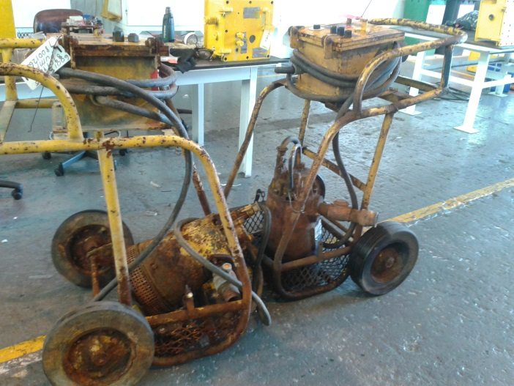 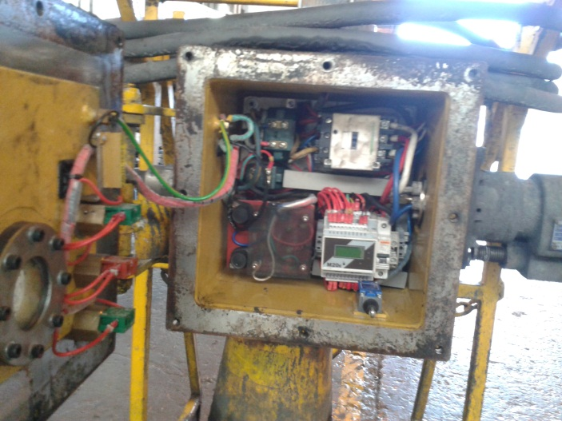

## [2] Electrical control panel for pump with circuit diagram with earth test lockout

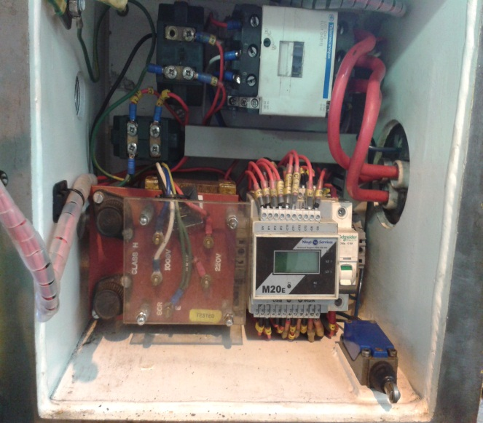

## [3] M20 motor protection relay

The M20 is a fully configurable motor protection relay and can be configured with a GUI (graphical user interface) configuration program which allows engineers and technicians to program this relay based and the M20 relay can be configured via USB as required. The configuration allows the engineer three inputs which can be configured as normally open or normally closed as well as four voltage free relay contacts which can be configured to operate from any input or motor protection function. Protection features include 3 phase thermal overload protection, over/under voltage protection, voltage and current unbalance protection and phase loss and phase rotation protection.

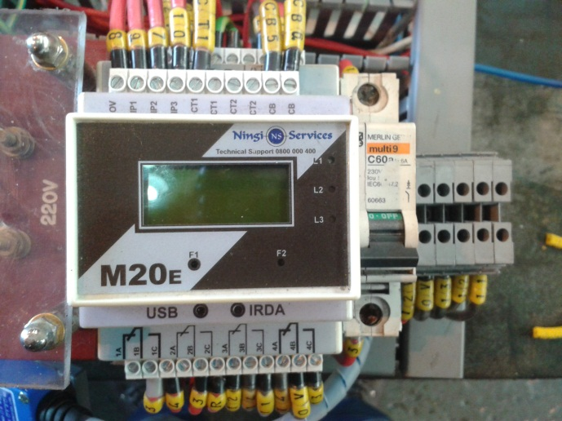

## [4] Complete process overview

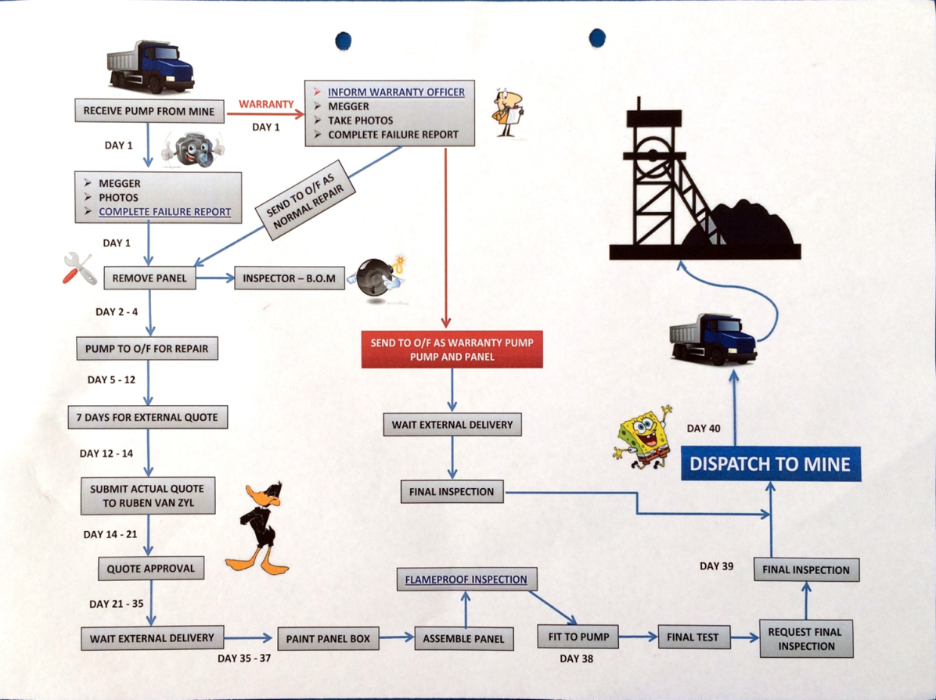

## [5] Repairs of motors

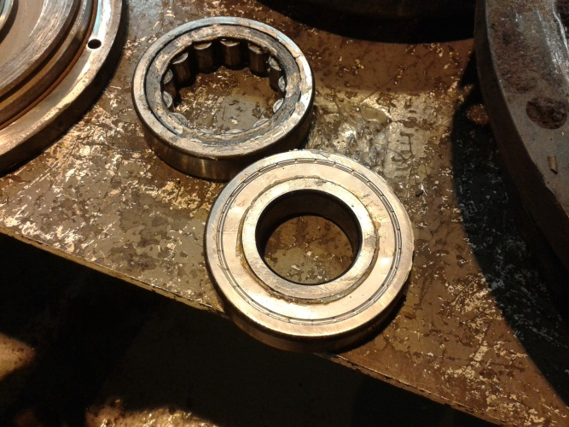b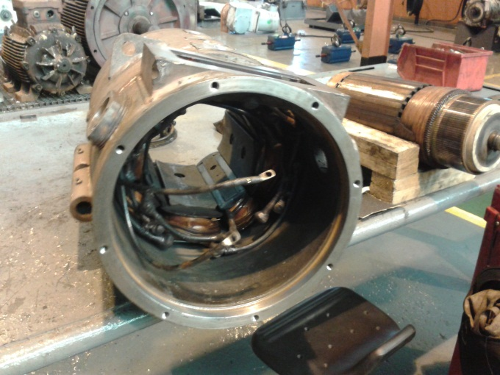

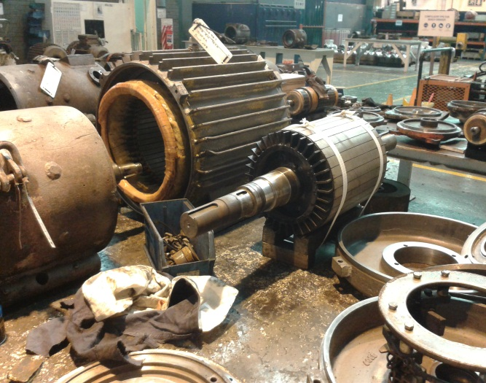 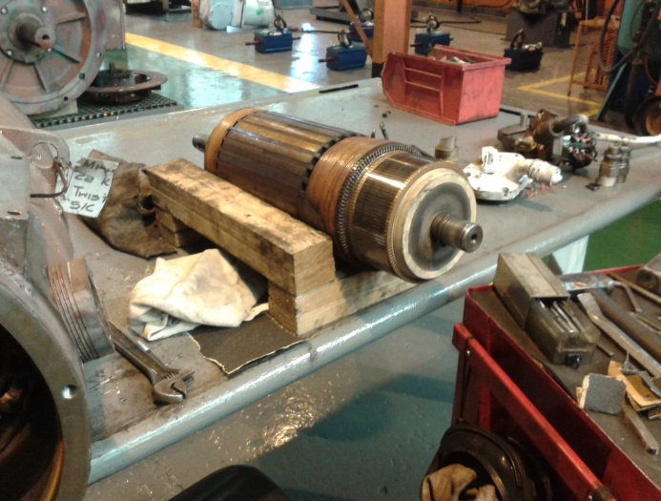

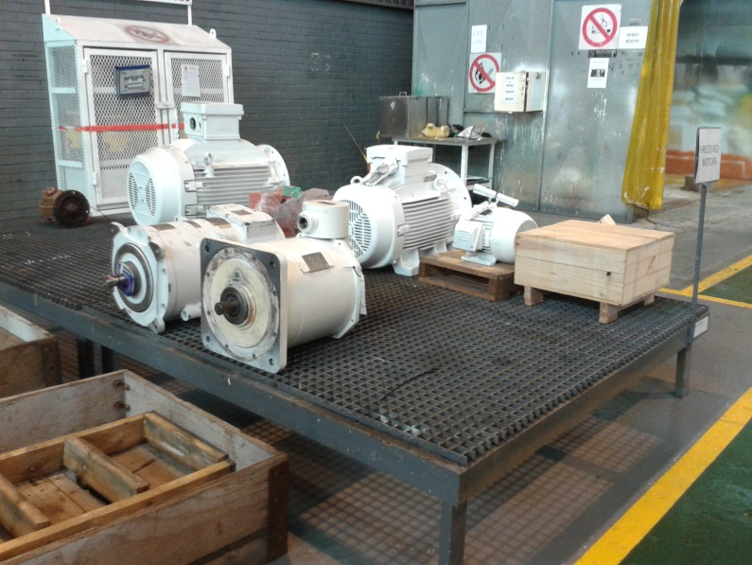

## [6] Risk assessment form and safety wear

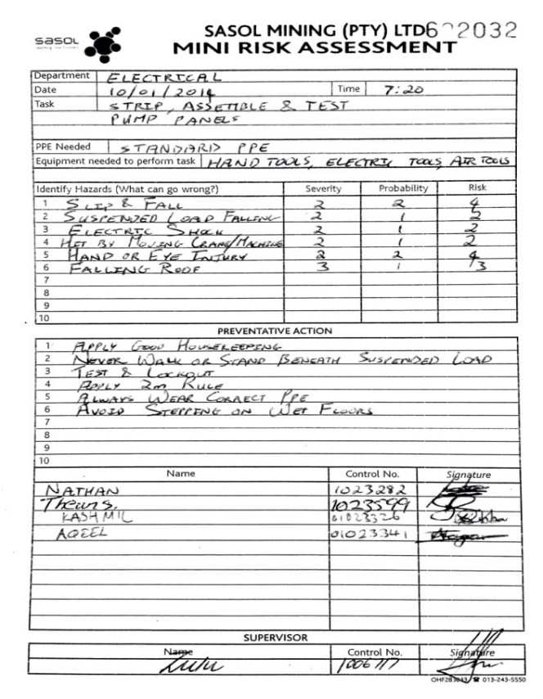

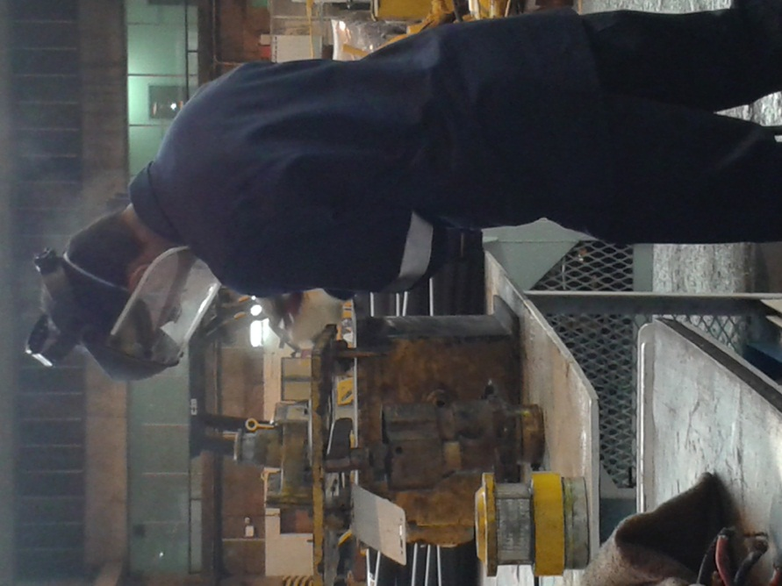

## [7] Repairs of electric pump panels

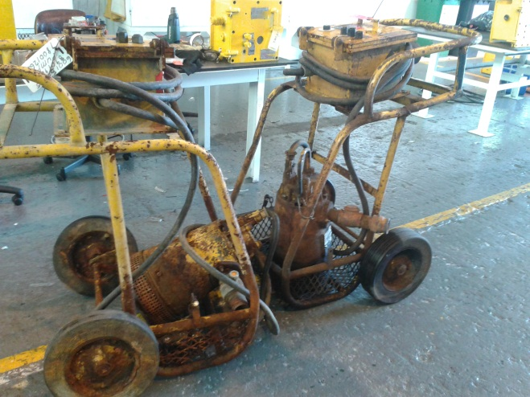 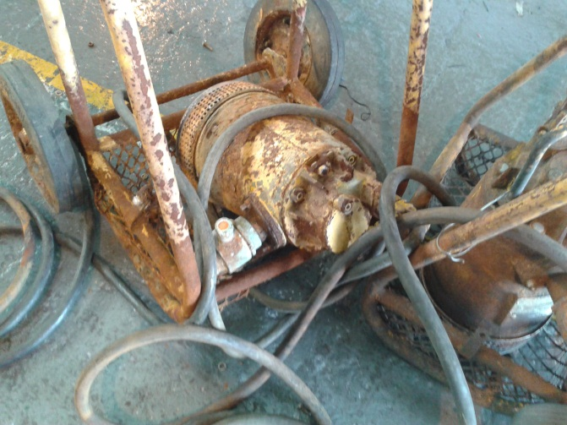

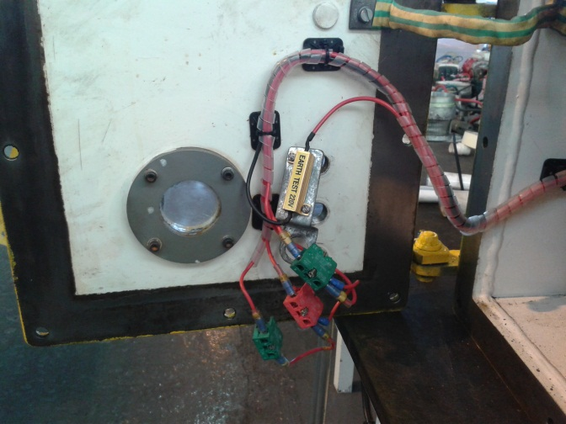 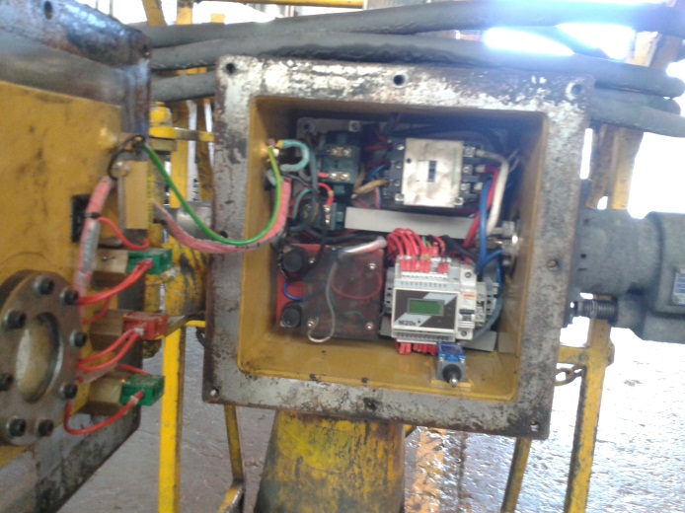

## [8] Final product after completion

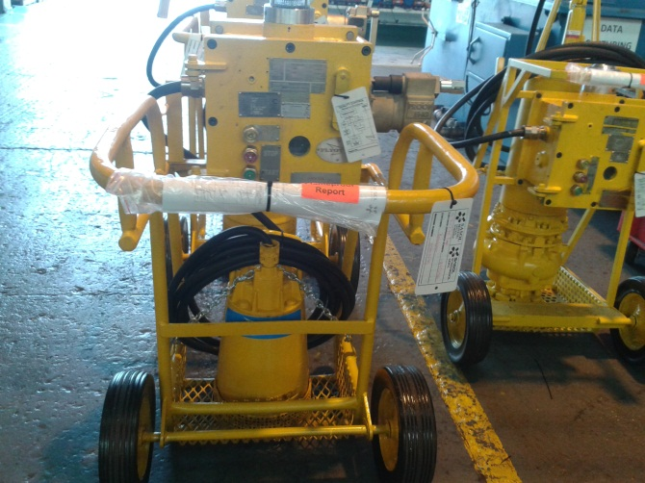 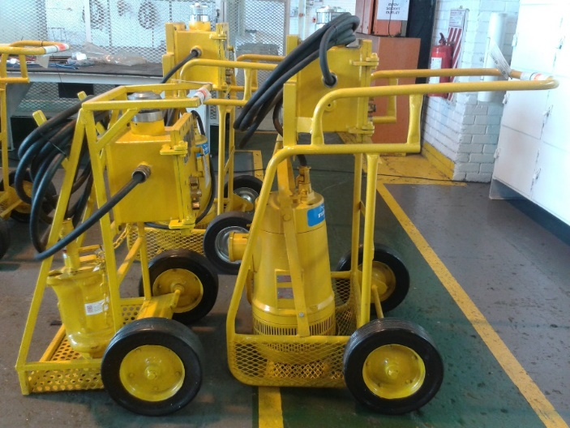

## [9] Flameproofing certificate and specifications

## [10] Earth fault lockout / circuit diagram of electric panel

## [11] Certificate and description of earth test lockout

## [12] Presentation done to line manager and other engineers